**PROGRAMS IN ARROW FUNCTION:**

1)Print odd numbers in an array:

let oddnumbers = (nums) =>{

    for(let i = 0;i<nums.length;i++){

        if(nums[i]%2==1){

            console.log(nums[i])

        }

    }

}

let arr = [1,2,3,4,5,6,7,8,9,10];

oddnumbers(arr);

**OUTPUT:**

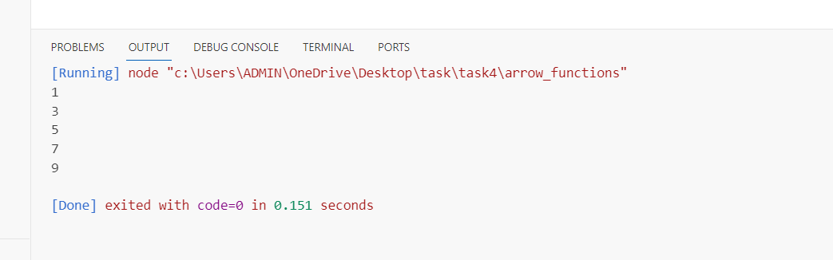

**-----------------------------------------------------------------------------------------------------------------**

**2)Convert all strings into title caps in a string array:**

let convertToTitleCase = (strings) => {

    for (let i = 0; i < strings.length; i++) {

      let words = strings[i].split(' ');

      for (let j = 0; j < words.length; j++) {

        // Capitalize the first letter of each word and append the rest of the word

        words[j] = words[j].charAt(0).toUpperCase()+words[j].slice(1);

      }

      strings[i] = words.join(' ');

    }

   console.log(strings);

}

const stringArray = ["hello world", "full stack mern", "how are you"];

convertToTitleCase(stringArray);

**Output:**

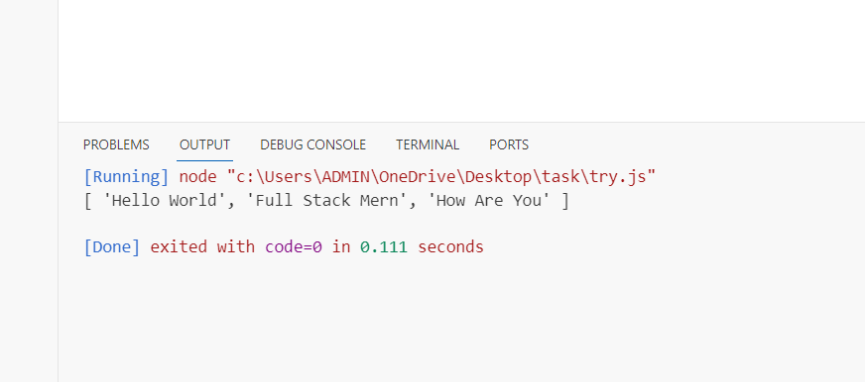

**-----------------------------------------------------------------------------**

**3) Sum of all numbers in an array:**

let sum =(nums) => {

        let total = 0;

        for (let i= 0;i<nums.length;i++){

            total += nums[i];

        }

        console.log(total);

    };

let numbers = [1, 2, 3, 4, 5, 6, 7, 8, 9, 10];

sum(numbers);

**OUTPUT:**

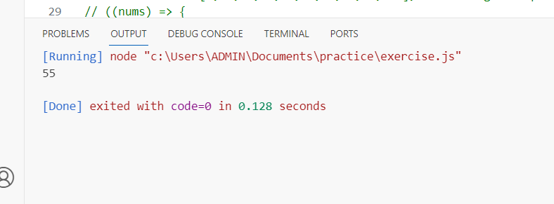

**-----------------------------------------------------------------------------------------------------------------**

**4) Return all the prime numbers in an array:**

let isPrime = (num) =>{

  for (let i = 2; i <= Math.sqrt(num); i++) {

      if (num % i === 0) return false; //

  }

  return true;

}

let numbers = [1,2,3,4,5,6,7,8,9,10];

const prime = [];

for (let index = 0; index < numbers.length; index++) {

  if (isPrime(numbers[index])) {

      prime.push(numbers[index])

  }

}

console.log("Prime numbers in the array:", prime);

**output:**

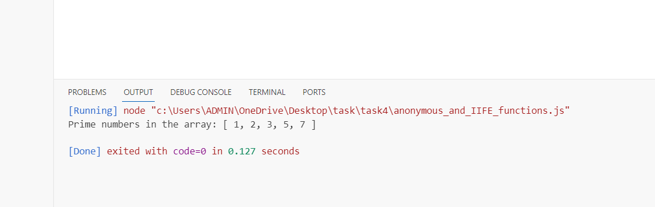

**----------------------------------------------------------------------------------------------------------------**

**5)Return all the palindromes in an array**

let ispalindrome = (words) => {

    let palindromes = [];

  for (let word of words){

     let reverse = '';

     for ( let index =word.length-1; index>=0; index--){

         reverse += word[index];

     }

     if (word === reverse){

         palindromes.push(word);

     }

   }

    return palindromes;

 }

const strings = ["level", "hello", "noon", "radar", "world", "deified"];

const palindromes = ispalindrome(strings);

console.log("Palindromes in the array:", palindromes);

**output:**

